Microsoft Office 365 for
Professionals and Small Businesses
Get the value and simplicity of Microsoft® Office 365 for small businesses, a set of web-enabled tools that let you access your email, documents, contacts, and calendars from virtually anywhere, on almost any device. The service brings together online versions of the best communications and collaboration tools from Microsoft, at a price that small businesses can afford.
Why Office 365?
Work from Virtually Anywhere
Be productive on the go.
Rich client access via Office applications on PCs and Macs.
View and edit documents with Office Web Apps across a broad range of browsers (Internet Explorer, Firefox, Safari).
Access your email from most browsers with Outlook Web App.
Access mail, contacts, calendar, and SharePoint® sites from mobile devices including Windows® Phones, Nokia, Android, iPhone and BlackBerry.

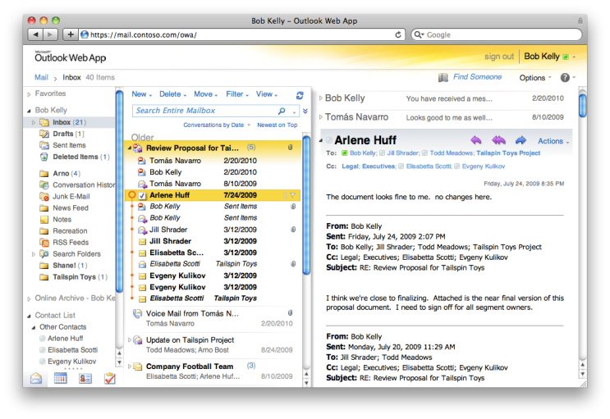
Web applications with cross-browser support
Collaborate Better
Work together, smarter.
Conduct online meetings with colleagues, partners, and customers, including audio, video and screen sharing.
Create sites to store your important office documents and work together with colleagues, partners, and customers.
Share your calendar with colleagues, partners, and customers.
Share important business information, including Access databases.
Simultaneously edit documents with your colleagues.

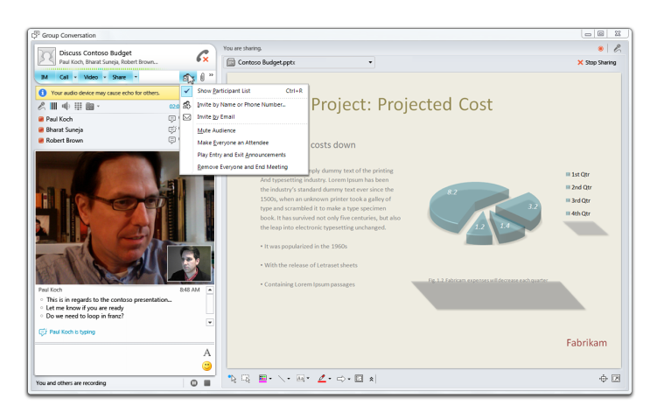
Online meeting presentation with PC-to-PC audio and video
Work with What You Know
Use familiar Office tools.
Works seamlessly with the programs you know and use most including Microsoft Outlook®, Word, Excel®, and PowerPoint®.
Outlook powered by Exchange Online provides powerful tools for managing your email, calendar, and contacts.
A familiar ribbon interface across the Office suite, including Web Apps.

Look Professional
Be what's next.
Easily design a professional looking public website.
Communicate with a domain-based email.
Interface with customers using professional communications and collaboration tools.
Deliver professional-looking documents to customers.

Easy-to-use web-based design tools

Overview of Services
The user’s home page for Office 365 for small businesses
The user’s home page for Office 365 for small businesses
Office Web Apps
Easily access, view, and edit documents directly from a web browser.
View and make light edits to Word, Excel, PowerPoint, and OneNote® documents.
Simultaneously edit Excel and OneNote documents with others in real-time.

Manage and share important documents to keep teams in synch, with SharePoint Online.
Work together more easily by giving partners access to the business information they need.
Maintain a professional-looking public website with easy-to-use templates.
Instant Messaging and Online Meetings
Find and connect with colleagues and customers from virtually anywhere with Microsoft Lync™ Online.
Gain rich presence information, IM, audio/video calls, and online meetings.
Make PC-to-PC voice and video calls and conduct rich online meetings—including audio, video, and web conferencing.
Access Virtually Anywhere
Synch email, calendar, and contacts across PC, phone, and browser with Exchange Online.
Easily manage email, calendar, and contacts from virtually anywhere.
Premium antivirus and anti-spam protection.

Pricing and Licensing
Price | Please see the Office 365 website for current pricing.
Number of Users | Organizations with 1–25 users  (maximum of 50).
Licensing | Available only under User Subscription Licenses (USL); not available under Microsoft Volume Licensing.
Subscription Terms | Available on a month-to-month basis with automatic renewal each month. Cancel at any time with no early termination fee.

Sign up for Office 365 today at www.office365.com.

